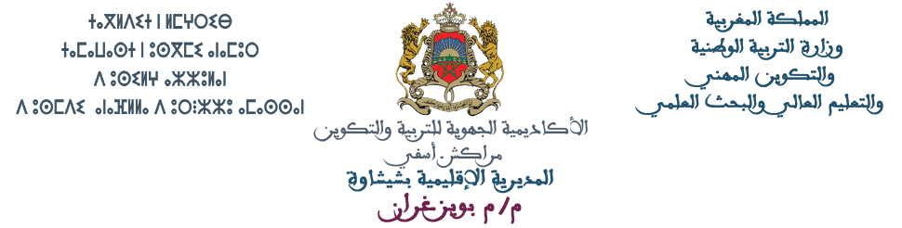

2ىęïиφJا
ﰎ ﺇﻋﺪﺍﺩ ﻫﺬﺍ ﺍﻟﺘﻘﻮﻳﻢ ﺑﺎﻻﺳﺘﻌﺎﻧﺔ ﺑﺎﻟﻨﻤﻮﺫﺝ ﺍﻟﺬﻱ ﺃﻋﺪﺗﻪ ﺍﳌﺪﻳﺮﻳﺔ ﺍﻹﻗﻠﻴﻤﻴﺔ ﺑﺄﺳﻔﻲ

ypiżиïJا pię ïJا
دةlg
i!µ Jا fJا


y µφJا رl Ęا
اJ µاءة واpœJ
لl φJا
1

1 ﻗﺮﺍﺀﺓ ﻧﺺ ﺑﺴﻴﻂ ﻭﻓﻬﻤﻪ؛
2 ﺗﻌﺮﻑ ﻛﻠﻤﺎﺕ ﻣﺘﻀﻤﻨﺔ ﻓﻲ ﻧﺺ ﻣﻌﻄﻰ؛

3 ﺗﺤﺪﻳﺪ ﻣﻌﻨﻰ ﻛﻠﻤﺎﺕ ﻣﺘﻀﻤﻨﺔ ﻓﻲ ﺍﻟﻨﺺ؛
4 ﺗﻌﺮﻑ ﺷﺨﺼﻴﺎﺕ ﺍﻟﻨﺺ؛

5 ﺗﻌﺮﻑ ﺍﻷﺣﺪﺍﺙ ﺍﻟﻮﺍﺭﺩﺓ ﻓﻲ ﺍﻟﻨﺺ؛
6 ﺗﻌﺮﻑ ﺃﻣﺎﻛﻦ ﺃﺣﺪﺍﺙ ﺍﻟﻨﺺ؛

7 ﺇﺗﻤﺎﻡ ﺟﻤﻞ ﺑﺎﻻﻋﺘﻤﺎﺩ ﻋﻠﻰ ﺻﻮﺭ؛
8 ﺇﺟﺮﺍﺀ ﺗﺤﻮﻳﻼﺕ ﺑﺎﺳﺘﻌﻤﺎﻝ ﺍﻟﻀﻤﺎﺋﺮ ﺍﻟﻤﻨﻔﺼﻠﺔ.
y µφJا رl Ęا
!lïhJا
لl φJا
2

1 ﺗﻜﻮﻳﻦ ﻛﻠﻤﺎﺕ ﺑﺎﺳﺘﻌﻤﺎﻝ ﺣﺮﻭﻑ ﻣﻌﻄﺎﺕ؛
2 ﺗﻜﻮﻳﻦ ﺟﻤﻞ ﺑﺎﺳﺘﻌﻤﺎﻝ ﻛﻠﻤﺎﺕ ﻣﻌﻄﺎﺕ؛ .

3 ﺗﺮﺗﻴﺐ ﺟﻤﻞ ﻟﺘﻜﻮﻳﻦ ﻧﺺ ﺫﻱ ﻣﻌﻨﻰ ﺑﺎﻻﻋﺘﻤﺎﺩ ﻋﻠﻰ ﺻﻮﺭ


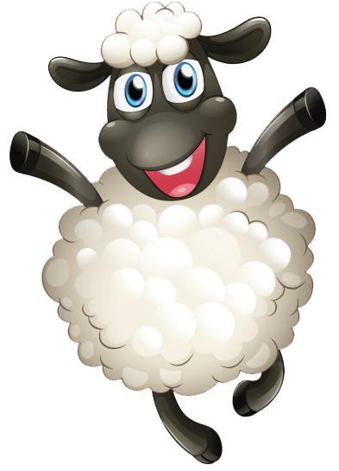ِﺑْﻨ ٌﺖ
تlφfhJا أµ أ
وفµ2fJ iφpïφJا
iiµφïJا
2
ُﻛَﺮ ٌﺓ
ٌﻑ َﺧُﺮﻭ
َﺳ َﻤ َﻜ ٌﺔ
َﺃ ْﺭَﻧ ٌﺐ
ِﻛَﺘﺎ ٌﺏ
َﺳﱠﻴﺎَﺭ ٌﺓ
ٌﻞ ْﻔ ِﻃ


ﻁ
ﺝ
ﺱ
ﻡ
ﻑ

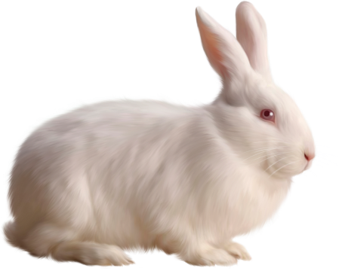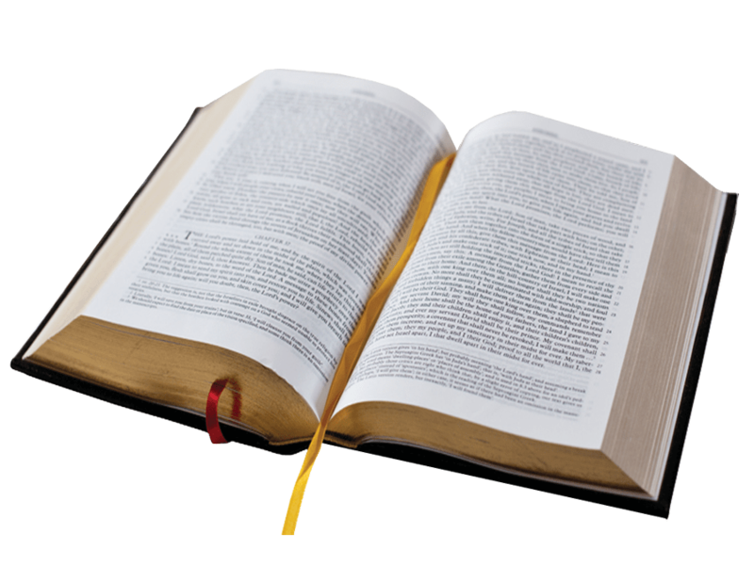 ْﻄَﺮ َﻗ ٌﺔ َﺗ ْﻤٌﺮ ِﻣ
أ µأ وأ }
nliφJا φfhJl! رةępJا
iiµφïJا
1
َﻃِﺮﻳ ٌﻖ
َﻗ ْﺮَﻳ ٌﺔ
َﺑ ﱠﻄ ٌﺔ ُﻛ ْﺮ ِﺳ ﱞﻲ
َﻤٌﺮ َﻤ ٌﻞ َﻗ ُﺫ ﱞﺏ َﺟ ِﺟ ْﺴٌﺮ
َﻣ ْﺴ ِﺠ ٌﺪ
َﻋ َﺴ ٌﻞ
ُﺗﻮ ٌﺕ ْﻮ ٌﺱ َﺼ ٌﺐ َﻗ َﺳﱠﻴﺎَﺭ ٌﺓ َﻗ َﻃﺎ ِﻭَﻟ ٌﺔ ُﻛَﺮ ٌﺓ
ْﻬٌﺮ َﻛْﻠ ٌﺐ ٌﻢ ُﻣ َﺳ ْﻬ ِﻗ ْﺮ ٌﺩ
َﺣ َﻤ ٌﻞ
ُﻛَﺮ ٌﺓ
ْﺴَﺘﺎ ٌﻥ ُﻋْﻠَﺒ ٌﺔ ٌﺔ ُﻓ ُﺑ ْﺮُﺗ َﻘﺎَﻟ ٌﻦ ُﺗ ﱠﻔﺎ َﺣ ٌﺔ ِﺳ ﱢﻜﻴ َﺳْﻴ ٌﻒ


أرï اµ2Jوف
رępJا ءlφnأ hرÉ
iiµφïJا
3

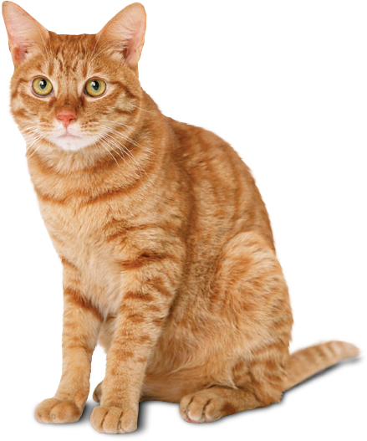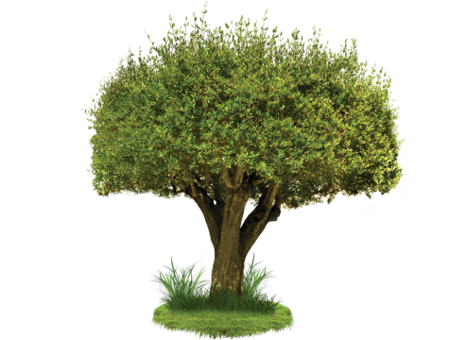ْﻫـ ـ ٌﺓ
َﺭ ـ َﺯ ـ
ٌُﺥ ـ ـْﺒـ
ٌﺯ ـ
َﺳـ ـ ـﺎ ـ َﺭ ـ ٌﺓ
ـﱠﻴـ ـ
َﺟـ ـ ٌﺓ
َﺭ ـ ﺷﹷ ـ
ِﻗـ
ٌﺓ ـ
ـ ﱠﻂ ـ

..................
أرï اµ2Jوف
تlφfh hرÉ
iiµφïJا
4
..............
.......................
..................
.................


ـ ِﻄـ ـَﺘـ
ٌﻝ
ُﻣـ
ـ ْﺴـ
ـﻴـ
ٌﻝ
ﺍ
ُﺑـ ْﺭ
َﻗـ ُﺗـ
ﻭ
ٌﺓ
َﺭ
ﺑﱡـ
َﺳـ
ﺍ
ِﻭ
َﻃـ
ٌﺓ َﻟـ
ﺍ
َﺩ
ٌﺓ
َﺟـ
َﺭ

.......................
.......................
.......................
.......................
.......................

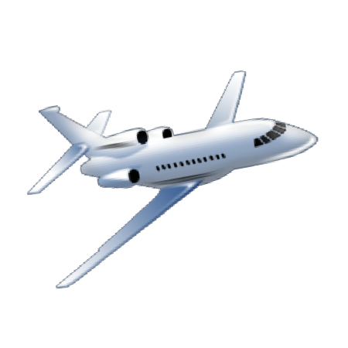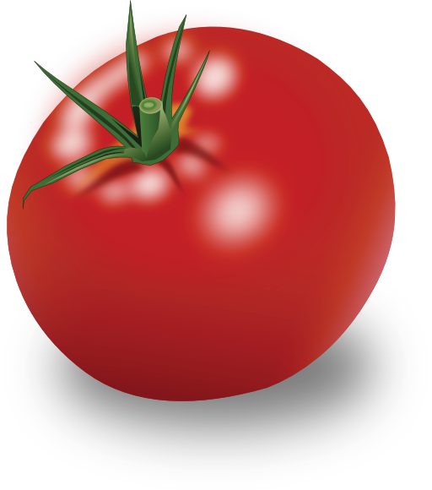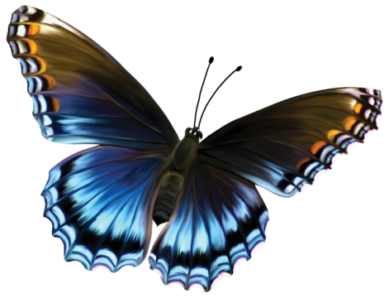ِﻣ َﻘ ﱞﺺ
أ µأ وأ i
رةępJا i ةµ φJا φfhJا
iiµφïJا
5
ُﻋ ْﺼ ُﻔﻮٌﺭ
َﺛﱠﻼ َﺟ ٌﺔ
َﺩﱠﺭﺍ َﺟ ٌﺔ

 َﻄَﺮ ٌﺓ َﻈ ٌﺔ ِﻣ ْﺴ ِﻣ ْﺤ َﻔ
َﺷ ٌﺔ ٌﻞ َﻓَﺮﺍ ِﻓﻴ
َﻤﺎ ِﻃ ٌﻢ ِﻣْﻠ َﻌ َﻘ ٌﺔ َﻃ
تlφfhJا ïأر
ة2ig fφ نęhÉ
َﻃﺎِﺋَﺮ ٌﺓ َﺳﱠﻴﺎَﺭ ٌﺓ

iiµφïJا
6


َﺃ ْﺟ َﻤ ُﻞ ـ َﻭ َﻃِﻨﻲ ـ ﺍ َﻷﻭ َﻃﺎ ِﻥ
ُﻣ ْﻤِﺘ َﻌ ٌﺔ ـ ُﻟ ْﻌَﺒ ٌﺔ ـ ﺍْﻟ َﻘ َﺪ ِﻡ ـ ُﻛَﺮ ُﺓ
................................................. .................................................

َﺳﺎِﺋ ٌﻖ ـ َﺃِﺑﻲ ـ َﻣﺎ ِﻫٌﺮ
ِﺇَﻟﻰ ـ َﺫ َﻫْﺒ ُﺖ ـ َﺻَﺒﺎ ًﺣﺎ ـ ﺍْﻟ َﻤ ْﺪَﺭ َﺳ ِﺔ
................................................. .................................................


}φ Jا ïأر
l iи! lp نęhÉ
iiµφïJا
7

َﺲ َﻣََﻼِﺑ ِﺴ ُﻪ ﺍْﻟ َﺠ ِﺪﻳ َﺪ َﺓ ـ ِﺑﺎْﻧ ِﻄَﻼ ِﻕ ﺍْﻟ َﻤ ْﻮ ِﺳ ِﻢ ﺍﻟ ِّﺪَﺭﺍ ِﺳ ِّﻲ ﺍْﻟ َﺠ ِﺪﻳ ِﺪ ـ ِﺍ ْﺳَﺘْﻴ َﻘ َﻆ َﺃ َﺣ ِﻤ ُﺪ َﺻَﺒﺎ ًﺣﺎ ـ
َﻭ ُﻛَّﻠ ُﻪ َﻧ َﺸﺎ ٌﻁ ـ َﻭَﻟِﺒ

َﻭ ُﺳُﺮﻭٍﺭ ـ
َﻓَﺮ ٍﺡ
ـ ِﻓﻲ
َﻓ ُﻄﻮَﺭ ُﻩ
ـ َﻭَﺗَﻨﺎ َﻭ َﻝ
َﻣ َﻊ ﺍَْﻷ ْﺻ ِﺪ َﻗﺎ ِﺀ
ـ َﻭﺍَّﺗ َﺠ َﻪ ِﺇَﻟﻰ ﺍْﻟ َﻤ ْﺪَﺭ َﺳ ِﺔ
َﻭ ْﺟ َﻬ ُﻪ
َﻏ ْﺴ َﻞ

....................................................................................................................................
....................................................................................................................................
....................................................................................................................................
...................................................................................................................................
¢iJا أµ إ
f nÉا i وأ
iiµφïJا
8

َﻣََﻼِﺑ ِﺴ ُﻪ
َﺲ َﻭَﻟِﺒ
ُﻪ َﻬ
ْﺟ َﻭ
َﻧ َﺸﺎ ٌﻁ ، َﻏ ْﺴ َﻞ
َﺻَﺒﺎ ًﺣﺎ َﻭ ُﻛَّﻠ ُﻪ
َﺃ َﺣ ِﻤ ُﺪ
ِﺍ ْﺳَﺘْﻴ َﻘ َﻆ

ِﻓﻲ َﻓَﺮ ٍﺡ
ِﺪ َﻗﺎ ِﺀ ْﺻ
َﻣ َﻊ ﺍَْﻷ
َﻓ ُﻄﻮَﺭ ُﻩ َﻭﺍَّﺗ َﺠ َﻪ ِﺇَﻟﻰ ﺍْﻟ َﻤ ْﺪَﺭ َﺳ ِﺔ
ﺍْﻟ َﺠ ِﺪﻳ َﺪ َﺓ َﻭَﺗَﻨﺎ َﻭ َﻝ

َﻭ َﺟ ُﺪﻭ
َﺑﺎ ِﺏ ﺍْﻟ َﻤ ْﺪَﺭ َﺳ ِﺔ،
ِﺳ ِﻢ ﺍﻟ ِّﺪَﺭﺍ ِﺳ ِّﻲ ﺍْﻟ َﺠ ِﺪﻳ ِﺪ. ِﻓﻲ
ِﺑﺎْﻧ ِﻄَﻼ ِﻕ ﺍْﻟ َﻤ ْﻮ
َﻭ ُﺳُﺮﻭٍﺭ

ُﺣَّﻠ ٍﺔ
ِﻬ ُﻢ، َﻭﺍْﻟ َﻤ ْﺪَﺭ َﺳ ُﺔ ِﻓﻲ َﺃْﺑ َﻬﻰ
ُﻣْﺒَﺘ ِﻬ ًﺠﺎ ِﺑ ُﻘ ُﺪﻭ ِﻣ
ﺍ ُﻷ ْﺳَﺘﺎ َﺫ


φfhJا !أر
µi2pJا lœli φ!
iiµφïJا
8

ٍﺓ َﺃ ْﺳ َﻮ ِﺀ َﻣْﻨ َﻈٍﺮ َﺃ ْﺣَﻠﻰ ُﺻﻮَﺭ
َﺃْﺑ َﻬﻰ ُﺣﱠﻠ ٍﺔ
ِﺍ ْﺳَﺘ َﻔﺎ َﻕ َﺃ ْﺣ َﻤ ُﺪ
َﻧﺎ َﻡ َﺃ ْﺣ َﻤ ُﺪ
ِﺍْﺑِﺘ َﻬﺎ ٍﺝ َﻭ ِﻏْﺒ َﻄ ٍﺔ
ُﺣ ْﺰ ٍﻥ َﻭَﺃَﻟ ٍﻢ
ِﺍ ْﺳَﺘْﻴ َﻘ َﻆ َﺃ ْﺣ َﻤ ُﺪ
َﻓَﺮ ٍﺡ َﻭ ُﺳُﺮﻭٍﺭ

...............................................................................؟ ُﺪ َﻤ ْﺣ َﺃ َﻆ َﻘ ْﺳَﺘْﻴ ﺍ َﻣَﺘﻰ
أ
f nÉا ¿f
iiµφïJا
9
ِﺇَﻟﻰ َﺃﻳ َﻦ ِﺍﱠﺗ َﺠ َﻪ َﺃ ْﺣ َﻤ ُﺪ َﻭَﺃ ْﺻ ِﺪ َﻗﺎ ُﺀ ُﻩ ؟................................................................
َﻣ ْﻦ َﻭ َﺟ َﺪ َﺃﺣ َﻤ ُﺪ َﻭَﺃ ْﺻ ِﺪ َﻗﺎ ُﺀ ُﻩ ِﻓﻲ ﺍْﻧِﺘ َﻈﺎِﺭ ِﻫ ُﻢ ؟..................................................
َﻛْﻴ َﻒ َﻭ َﺟ َﺪ َﺃﺣ َﻤ ُﺪ َﻭَﺃ ْﺻ ِﺪ َﻗﺎ ُﺀ ُﻩ ﺍْﻟ َﻤ ْﺪَﺭ َﺳ َﺔ ؟........................................................

َﺪﺓ ِﺪﻳ َﺠ ﺍْﻟ ُﻪ ِﺴ َﻣََﻼِﺑ َﻆ َﻘ ْﺳَﺘْﻴ ﺍ
φfh }h !أر
lœ nlii lφ!
iiµφïJا
10

ِﻬ ًﺠﺎ ِﺑ ُﻘ ُﺪﻭ ِﻣ ِﻬ ُﻢ
ﺍ ُﻷ ْﺳَﺘﺎ َﺫ ُﻣْﺒَﺘ
ﺍﱠﺗ َﺠ َﻪ

َﻣ َﻊ ﺍَْﻷ ْﺻ ِﺪ َﻗﺎ ِﺀ
ِﺇَﻟﻰ ﺍْﻟ َﻤ ْﺪَﺭ َﺳ ِﺔ
َﻟِﺒ َﺲ

َﺻَﺒﺎ ًﺣﺎ
φfh }h !أر
lœ nlii lφ!
iiµφïJا
10
َﺃ َﺣ ِﻤ ُﺪ
َﻭ َﺟ ُﺪﻭ


َﺻَﺒﺎ ًﺣﺎ
ﺍ ْﺳَﺘْﻴ َﻘ َﻆ
َﺃَﻧﺎ



َﺻَﺒﺎ ًﺣﺎ َﺻَﺒﺎ ًﺣﺎ َﺻَﺒﺎ ًﺣﺎ َﺻَﺒﺎ ًﺣَﺎ
ْﺳَﺘْﻴ َﻘ ْﻈ ِﺖ َﻘ ْﻈُﺘ َﻤﺎ ﺍ ْﻈ ُﺖ ﺍ ْﺳَﺘْﻴ ْﻢ ﺍ ْﺳَﺘْﻴ َﻘ ﺍ ْﺳَﺘْﻴ َﻘ ْﻈُﺘ
َﺃْﻧ ِﺖ

َﻤﺎ ْﻢ َﺃْﻧُﺘ َﻮ َﺃْﻧُﺘ ُﻫ


2œиφJا i µ أ
}φ iEi y
iiµφïJا
11






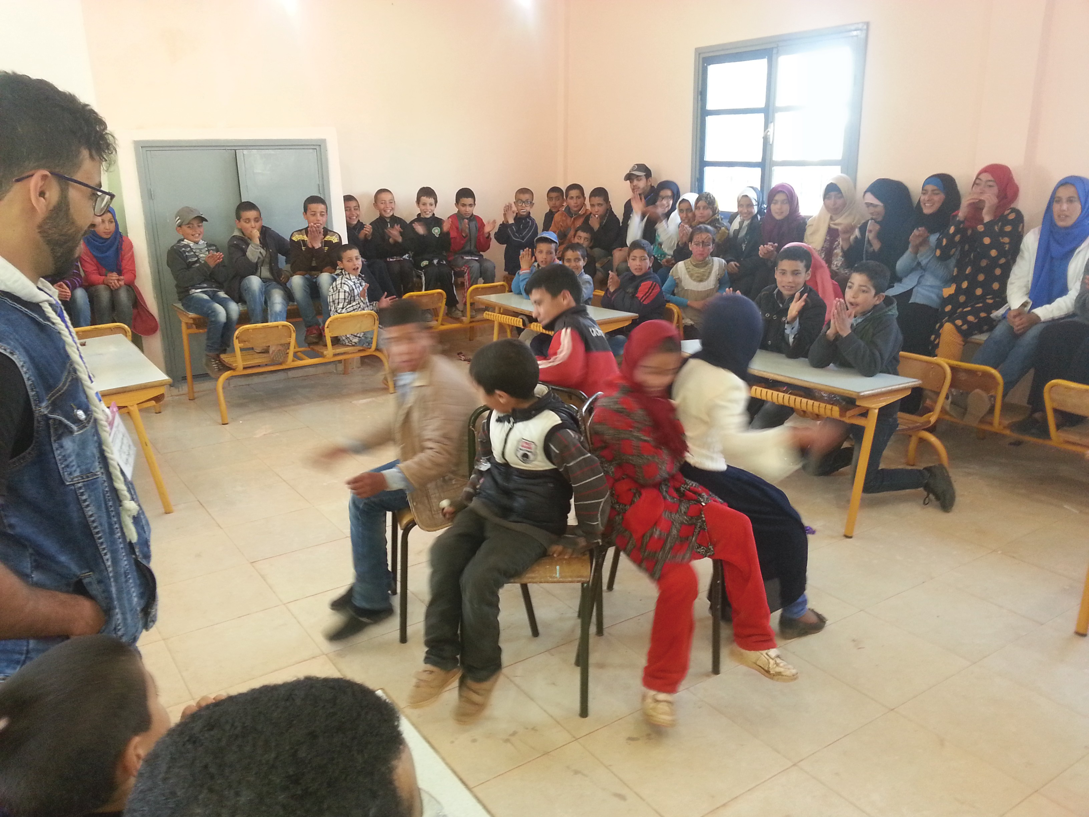......................................................................................................................
......................................................................................................................
......................................................................................................................
أ
ïhوأ
iiµφïJا
12
ش � ج � �q� � ف � ع � د � �� � ��� � ط � �Z � س

................................................................................................
................................................................................................

ypiżиïJا pię ïJا
دةlg
i!µ Jا fJا
2 ىęïиφJا

أ
ïhوأ

����� � ر��� � ��درا � ��� � ر���� �
..................................................................................................
..................................................................................................
ط��ì ą�Zو �a��ę �e�أ ���z�ا
أ
ïhوأ
iiµφïJا
12

iiµφïJا
12

��ر��

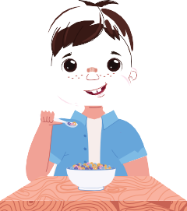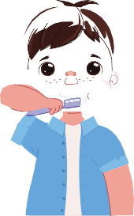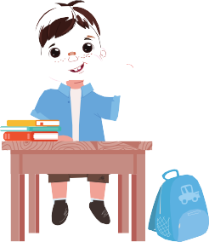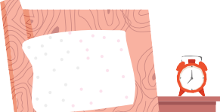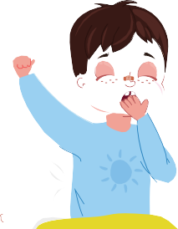
..................................................................................................
..................................................................................................
nliφJا نlhφJا y 4 ¿Jإ 1 ig مl رÉا !lïh!
2ig ¢ ¿f لęp2fJ
}φ Jا ïأر
رępJl! lii ïиg
iiµφïJا
13
ِﺍ ْﺳَﺘْﻴ َﻘ َﻆ َﺃ َﺣ ِﻤ ُﺪ َﺻَﺒﺎ ًﺣﺎ
َﻏ ْﺴ َﻞ َﻭ ْﺟ َﻬ ُﻪ
ﺍَّﺗ َﺠ َﻪ ِﺇَﻟﻰ ﺍْﻟ َﻤ ْﺪَﺭ َﺳ ِﺔ
َﺗَﻨﺎ َﻭ َﻝ َﻓ ُﻄﻮَﺭ ُﻩ

